**How to Generate password for Gmail**

Step1: Go to your Google Account and check if 2-step Authentication is enabled or not.  
If not enabled please enable it using your phone number

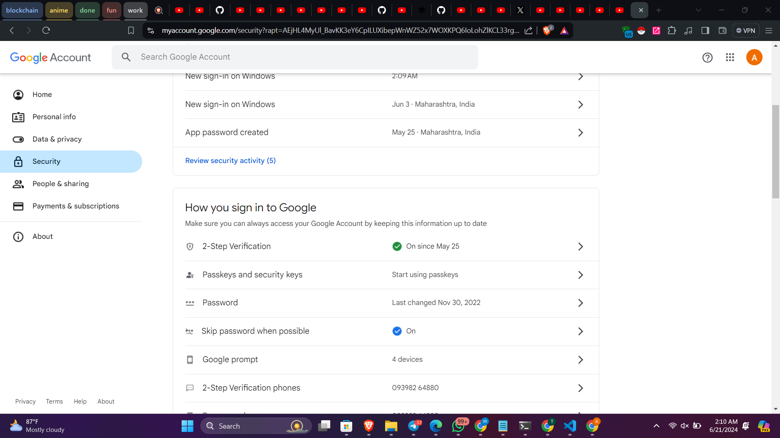

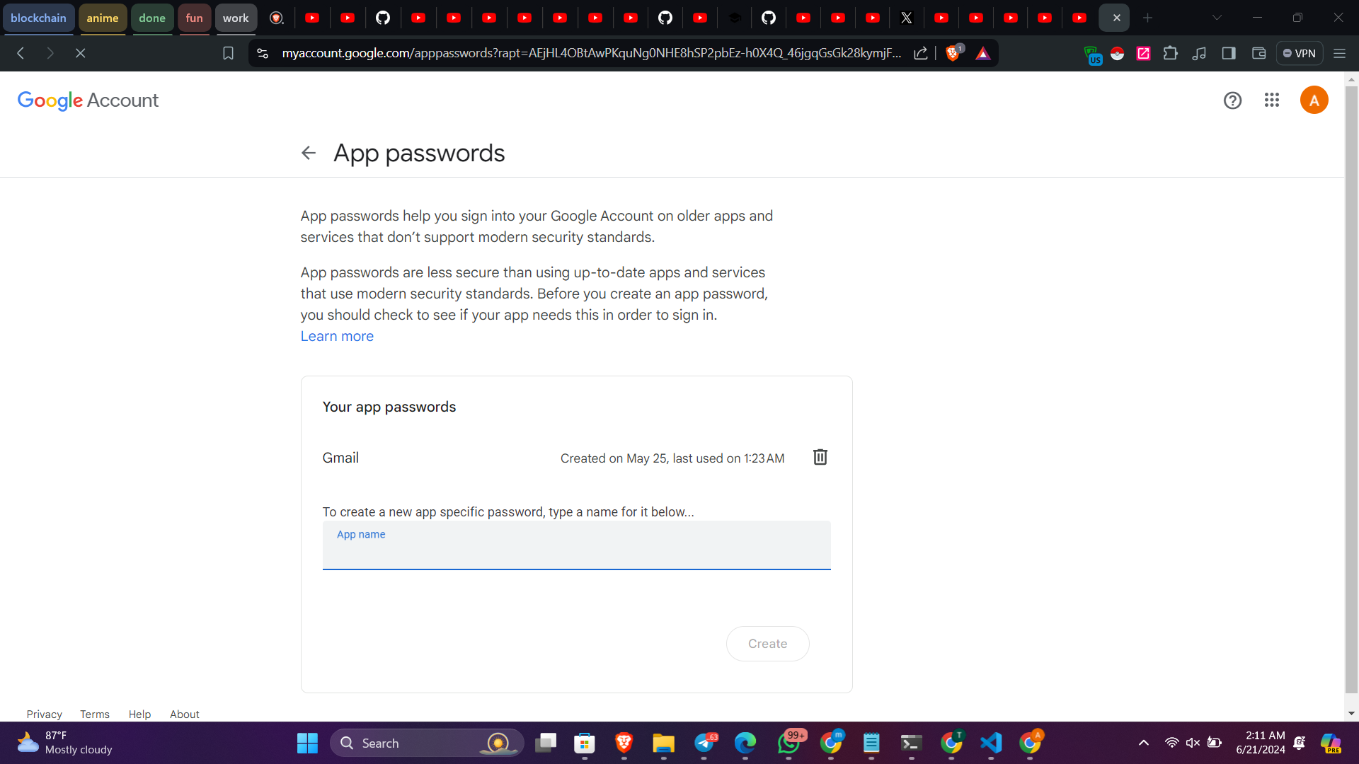Step2: In the search bar , Search for App Passwords

In the App Passwords create a app name and then the app password will be shown like the below example

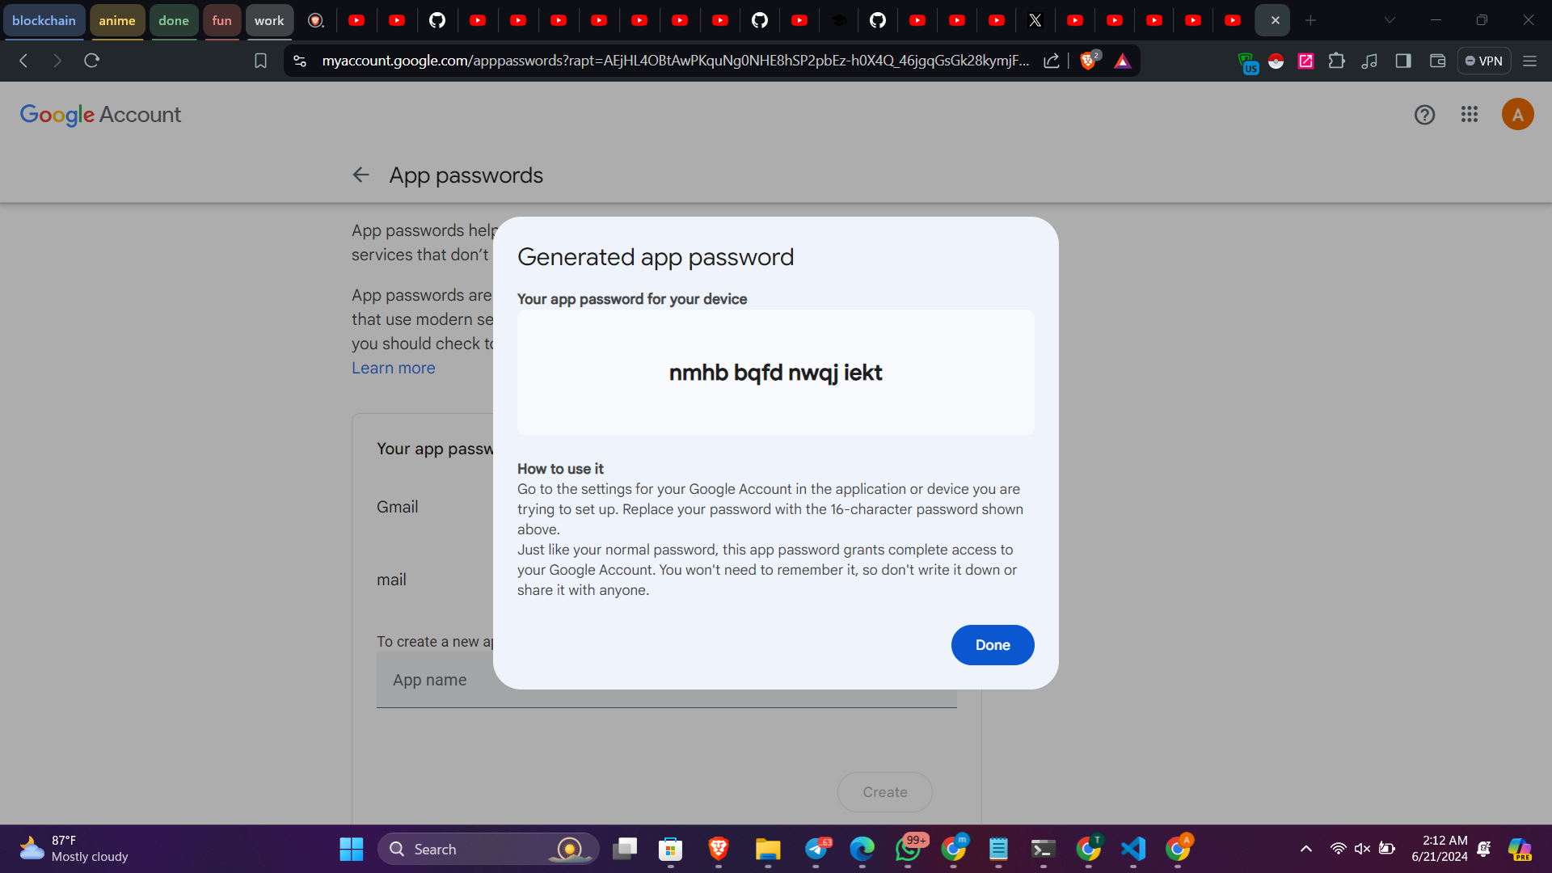

The same way you can create an app password for gmail account